**IP Leak**

**Cyber Intel**

# Executive Summary

IPLeak is a powerful online tool designed to assist internet users in checking their Internet Protocol (IP) address and detecting possible leaks. It provides a comprehensive analysis of your IP address, ensuring that you are using proper security measures while browsing the web. The website offers various features, including DNS leak test, WebRTC leak test, IPv6 leak test, and email tracing capabilities. By utilizing these tools, users can identify potential vulnerabilities or privacy breaches in their network connections and take appropriate actions to safeguard their online activities. IPLeak.net acts as a reliable resource for individuals concerned about maintaining anonymity and protecting their digital identity while surfing the internet.

# Index

**Executive Summary 2**

**Index 2**

**1. Introduction 2**

**2. Tool Details 2**

**3. Installation 3**

**4. Execution 3**

**5. Scope and Limitations 3**

**6. Conclusion 3**

**7. References (if any) 4**

# Introduction

The IPLeak tool is a powerful online resource designed to assist internet users in ensuring their online privacy and security. It offers comprehensive features such as DNS leak test, WebRTC leak test, IPv6 leak test, and email tracing capabilities. By utilizing these tools, individuals can identify potential vulnerabilities or leaks in their network connections and take appropriate actions to safeguard their digital identity.

The tool provides detailed analysis of the user's IP address, including geolocation, ISP details, and connection type. It helps detect if DNS requests are leaking or if the real IP address is exposed through WebRTC technology when using VPNs or proxies. Additionally, it examines the compatibility of network connections with IPv6 without any leakage issues that could compromise privacy. IPLeak also includes email tracing functionality for analysing headers from received emails to identify potential phishing attempts or suspicious sources of communication.

While the tool has its limitations and may not uncover all possible vulnerabilities in every scenario due to individual network configurations and settings, it serves as a valuable resource for enhancing online safety.

# Tool Details

Tool available at – <https://ipleak.net>

Accessed –

* using Microsoft Edge
* on 24 September 2023
* no VPN required

Use case list –

* Checking for DNS leaks: IPLeak allows users to verify if their DNS requests are leaking, which can potentially compromise their privacy and security.
* Detecting WebRTC leaks: WebRTC technology can inadvertently reveal a user's IP address even when using VPNs or proxies. IPLeak helps identify such leaks and provides recommendations to fix them.
* Testing IPv6 connectivity: As internet service providers transition to IPv6, it is essential to ensure that your network connection supports this protocol without any leakage issues. This tool can help detect potential vulnerabilities in IPv6 connections.
* Assessing VPN effectiveness: Users can use this tool while connected to a VPN service to confirm whether the assigned IP address matches the expected location and if there are any IP leaks occurring during the connection.
* Email tracing capabilities: IPLeak also offers email tracing functionality, allowing users to analyse headers from received emails.

# Installation

No installation required; Fake Name Generator Tool can be directly accessed using a browser by visiting link – <https://www.ipleak.net>

# Execution

* 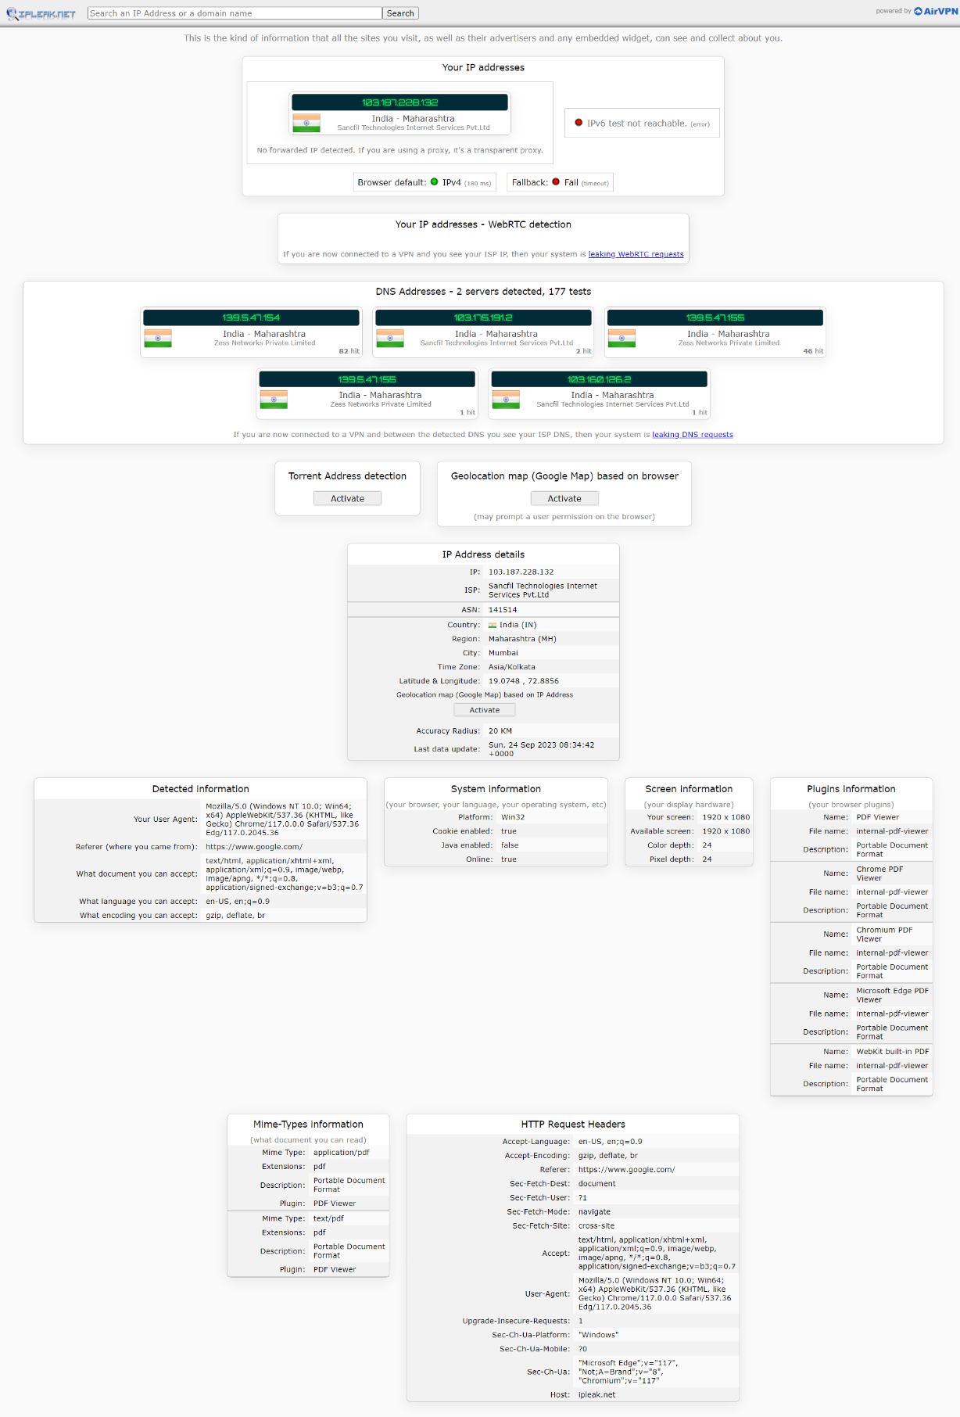Running IPLeak without VPN on Microsoft Edge –
* Running IPLeak with (ProtonVPN) VPN on Microsoft Edge –

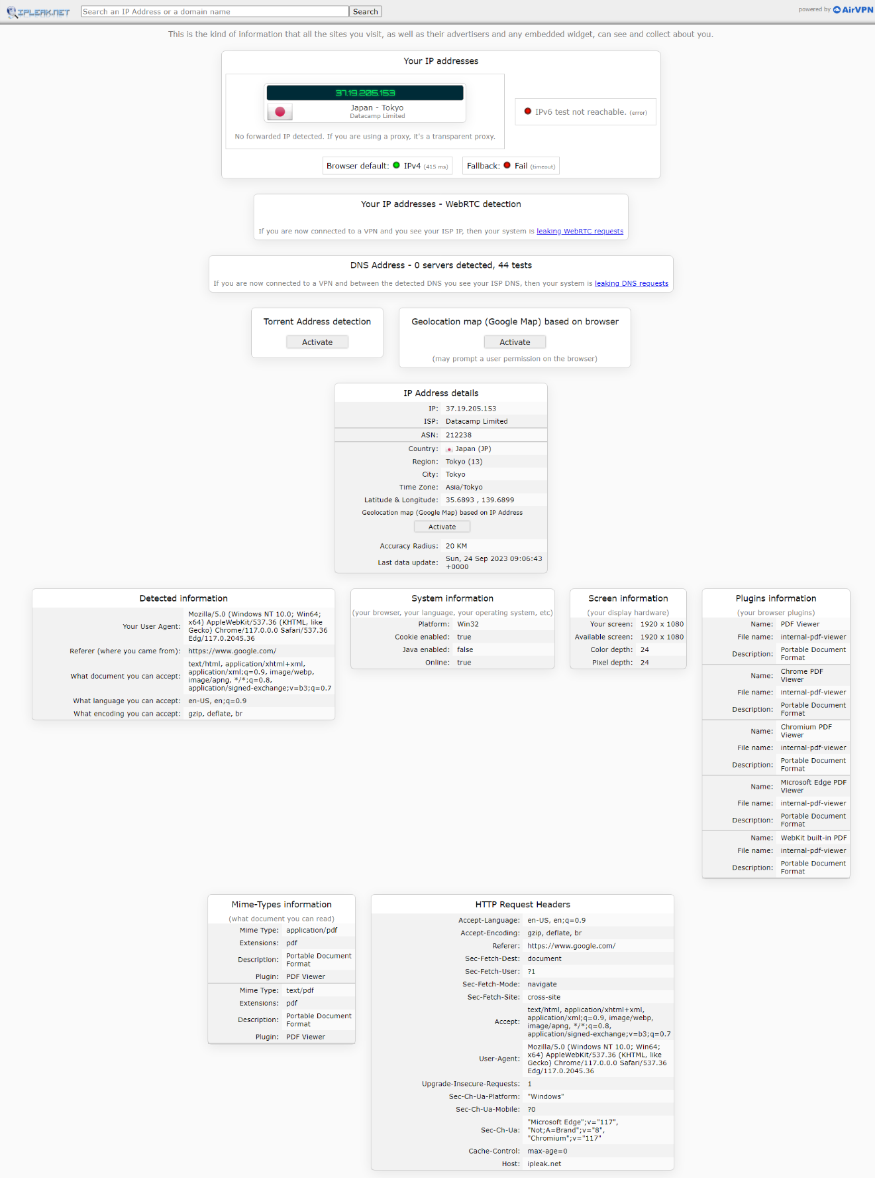

* Running IPLeak without VPN on Tor Browser –

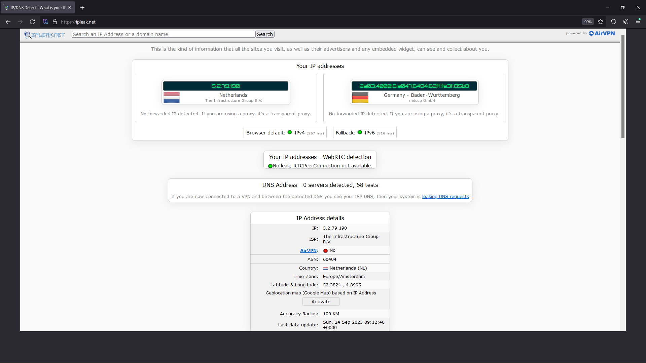

* Running IPLeak with (ProtonVPN) VPN on Tor Browser –

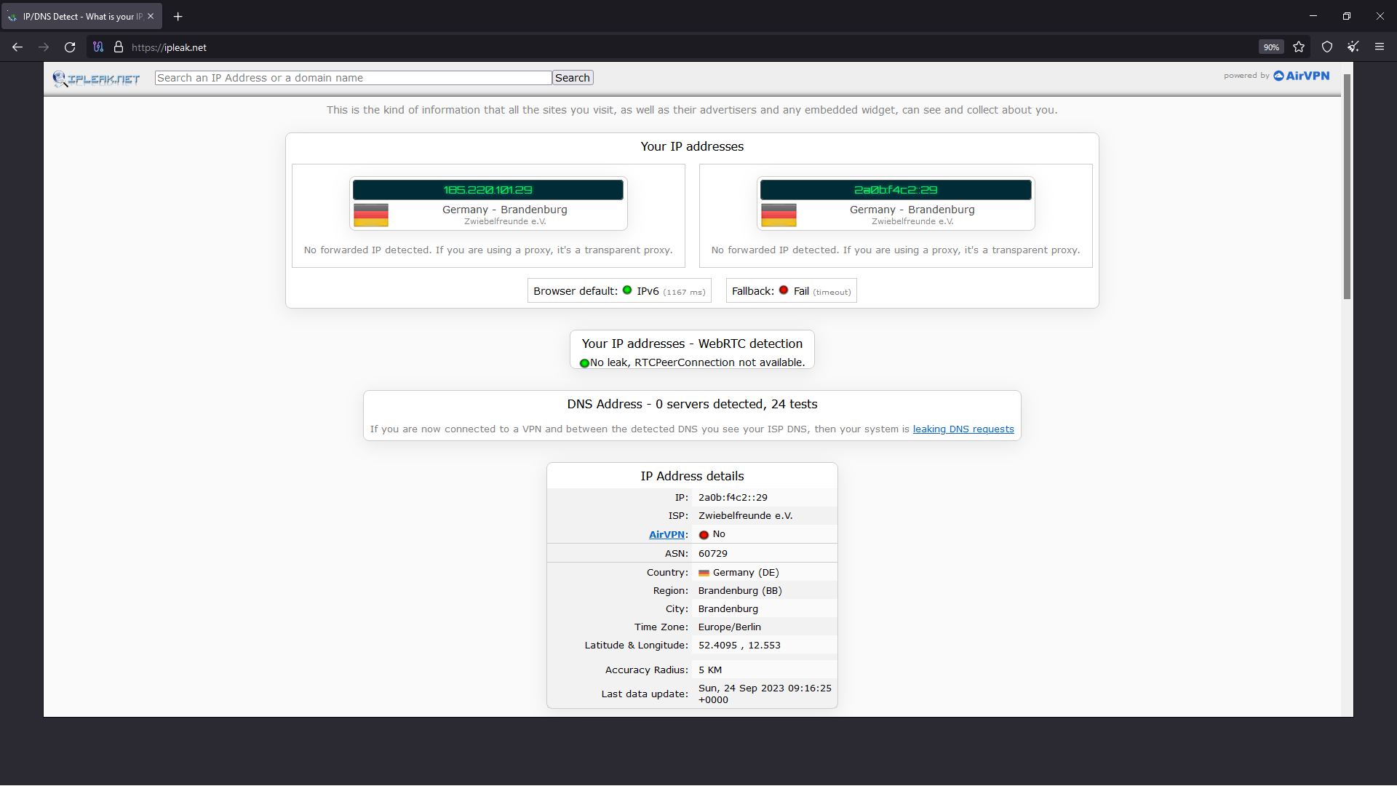

# Scope and Limitations

IPLeak provides detailed information about your IP address, including geolocation, ISP details, and connection type. It checks if your DNS requests are leaking and identifies any potential vulnerabilities in your network configuration. IPLeak helps detect if your real IP address is exposed through WebRTC technology when using VPNs or proxies. It examines whether your network connection supports IPv6 without any leakage issues that could compromise privacy. IPLeak allows users to analyse email headers for potential phishing attempts or suspicious sources.

While IPLeak provides comprehensive testing for various types of leaks, it may not uncover all possible vulnerabilities or leaks present in every scenario. The accuracy of the results heavily depends on the user's network configuration and settings; therefore, false positives or negatives can occur due to individual setups. As an online tool, a stable internet connection is necessary to access and utilize its features effectively. The tool focuses primarily on identifying IP leaks and providing related information; it does not include malware scanning or analysis capabilities. It is important to note that while helpful, this tool should be used as part of a broader security strategy rather than solely relying on its findings for complete protection against data leaks or privacy breaches.

# Conclusion

IPLeak is an essential tool for individuals seeking to protect their online privacy and security. With its comprehensive features, including DNS leak test, WebRTC leak test, IPv6 leak test, and email tracing capabilities, users can identify potential vulnerabilities in their network connections. By utilizing IPLeak.net's analysis and detection capabilities, users can ensure that their IP address remains secure and that no leaks compromise their anonymity. The tool provides valuable insights into the user's network setup and helps identify any potential risks or breaches.

# References

* <https://ipleak.net/>
* <https://www.torproject.org/>
* <https://protonvpn.com/>